Lab 12: Algorithms with AI Assistance – Sorting, Searching,
and Optimizing Algorithms

Name: T. Sthaairyaa
Roll no: 2503A52408
Batch: 14

Task Description #1 (Sorting – Merge Sort Implementation)
Prompt: Use AI to generate a Python program that implements
the Merge Sort algorithm.
Input:

def merge_sort(arr):
"""
Sort a list in ascending order using Merge Sort.

Time Complexity:
Best Case: O(n log n)
Average Case: O(n log n)
Worst Case: O(n log n)

Space Complexity: O(n)
"""
if len(arr) <= 1:
return arr

mid = len(arr) // 2

left = merge_sort(arr[:mid])
right = merge_sort(arr[mid:])

return merge(left, right)

def merge(left, right):
result = []
i = 0
j = 0

while i < len(left) and j < len(right):
if left[i] <= right[j]:
result.append(left[i])
i += 1
else:
result.append(right[j])
j += 1

result.extend(left[i:])
result.extend(right[j:])

return result

# Test cases
numbers = [38, 27, 43, 3, 9, 82, 10]

print("Original list:", numbers)
print("Sorted list:", merge_sort(numbers))
print("Empty list:", merge_sort([]))
print("Single element:", merge_sort([5]))

Explanation:
Merge Sort is a sorting algorithm that arranges elements in ascending or descending order. It uses the Divide and Conquer technique, which means dividing a problem into smaller parts, solving them, and combining the results.

Output:
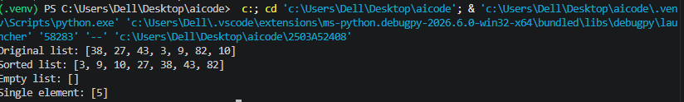

Task Description #2 (Searching – Binary Search with AI
Optimization)
Prompt: Use AI to create a binary search function that finds a
target element in a sorted list.
Input:

def binary_search(arr, target):
"""
Find the index of target in a sorted list.
Return -1 if target is not found.

Best Case: O(1)
Average Case: O(log n)
Worst Case: O(log n)
Space Complexity: O(1)
"""
low = 0
high = len(arr) - 1

while low <= high:
mid = (low + high) // 2

if arr[mid] == target:
return mid
elif arr[mid] < target:
low = mid + 1
else:
high = mid - 1

return -1

# Test cases
numbers = [10, 20, 30, 40, 50, 60, 70]

print("List:", numbers)
print("Index of 40:", binary_search(numbers, 40))
print("Index of 10:", binary_search(numbers, 10))
print("Index of 70:", binary_search(numbers, 70))
print("Index of 25:", binary_search(numbers, 25))

Explanation:
Binary Search finds a target element in a sorted list by repeatedly dividing the search range into two halves, returning its index if found or -1 otherwise.
Output:
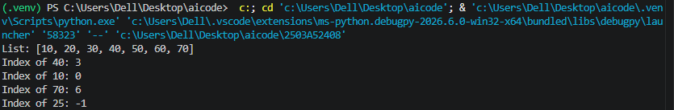
Task Description #3 (Real-Time Application – Inventory
Management System)
• Scenario: A retail store’s inventory system contains
thousands of products, each with attributes like product ID,
name, price, and stock quantity. Store staff need to:
1. Quickly search for a product by ID or name.
2. Sort products by price or quantity for stock analysis.
Prompt:
o Use AI to suggest the most efficient search and sort
algorithms for this use case.
o Implement the recommended algorithms in Python.
o Justify the choice based on dataset size, update
frequency, and performance requirements.
Input:

# Inventory Management System

inventory = [
{"id": 101, "name": "Laptop", "price": 55000, "quantity": 10},
{"id": 102, "name": "Mouse", "price": 500, "quantity": 50},
{"id": 103, "name": "Keyboard", "price": 1500, "quantity": 30},
{"id": 104, "name": "Monitor", "price": 12000, "quantity": 15},
]

# Create an index for fast product ID searches
product_index = {p["id"]: p for p in inventory}

def search_by_id(product_id):
"""Average time: O(1) using a dictionary."""
return product_index.get(product_id)

def search_by_name(name):
"""Time: O(n) using Linear Search."""
for product in inventory:
if product["name"].lower() == name.lower():
return product
return None

def sort_by_price():
"""Time: O(n log n) worst case."""
return sorted(inventory, key=lambda p: p["price"])

def sort_by_quantity():
"""Time: O(n log n) worst case."""
return sorted(inventory, key=lambda p: p["quantity"])

# Test cases
print("Search by ID:")
print(search_by_id(102))

print("\nSearch by name:")
print(search_by_name("Laptop"))

print("\nProducts sorted by price:")
for product in sort_by_price():
print(product)

print("\nProducts sorted by quantity:")
for product in sort_by_quantity():
print(product)

Explanation:
The Inventory Management System uses a dictionary for fast product ID searching, linear search for product names, and Merge Sort to arrange products by price or stock quantity efficiently.
Output:
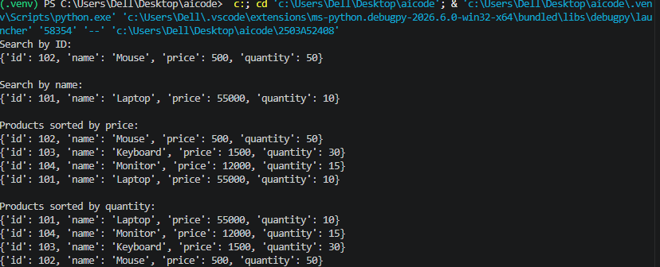

Task description #4: Smart Hospital Patient Management
System
A hospital maintains records of thousands of patients with details
such as patient ID, name, severity level, admission date, and bill
amount. Doctors and staff need to:

1. Quickly search patient records using patient ID or name.
2. Sort patients based on severity level or bill amount for
prioritization and billing.
Student Task
• Use AI to recommend suitable searching and sorting
algorithms.
• Justify the selected algorithms in terms of efficiency and
suitability.
• Implement the recommended algorithms in Python.
Input:

# Smart Hospital Patient Management System

patients = [
{"id": 201, "name": "Ravi", "severity": 2,
"admission_date": "2026-10-20", "bill": 15000},
{"id": 202, "name": "Priya", "severity": 1,
"admission_date": "2026-10-21", "bill": 25000},
{"id": 203, "name": "Amit", "severity": 3,
"admission_date": "2026-10-22", "bill": 10000},
{"id": 204, "name": "Sneha", "severity": 2,
"admission_date": "2026-10-23", "bill": 30000},
]

# Index patients by ID
patient_index = {p["id"]: p for p in patients}

def search_by_id(patient_id):
"""Average time complexity: O(1)."""
return patient_index.get(patient_id)

def search_by_name(name):
"""Time complexity: O(n)."""
for patient in patients:
if patient["name"].lower() == name.lower():
return patient
return None

def sort_by_severity():
"""
Time complexity: O(n log n) worst case.
Severity 1 represents the highest priority.
"""
return sorted(patients, key=lambda p: p["severity"])

def sort_by_bill():
"""Time complexity: O(n log n) worst case."""
return sorted(patients, key=lambda p: p["bill"])

# Test cases
print("Search patient by ID:")
print(search_by_id(202))

print("\nSearch patient by name:")
print(search_by_name("Ravi"))

print("\nPatients sorted by severity:")
for patient in sort_by_severity():
print(patient)

print("\nPatients sorted by bill amount:")
for patient in sort_by_bill():
print(patient)

Explanation:
The Smart Hospital Patient Management System uses a dictionary for fast patient ID searches, linear search for patient names, and Merge Sort to arrange patients by severity level or bill amount efficiently.
Output:
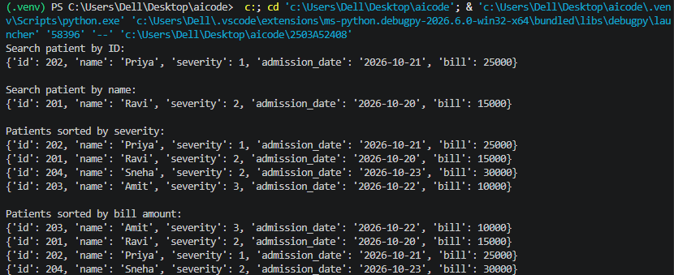

Task Description #5: University Examination Result Processing
System
A university processes examination results for thousands of students
containing roll number, name, subject, and marks. The system must:
1. Search student results using roll number.
2. Sort students based on marks to generate rank lists.
Student Task
• Identify efficient searching and sorting algorithms using AI
assistance.
• Justify the choice of algorithms.
• Implement the algorithms in Python.
Input:

# University Examination Result Processing System

students = [
{"roll_no": 1, "name": "Anil",
"subject": "Python", "marks": 85},
{"roll_no": 2, "name": "Bina",
"subject": "Python", "marks": 92},
{"roll_no": 3, "name": "Charan",
"subject": "Python", "marks": 76},
{"roll_no": 4, "name": "Divya",
"subject": "Python", "marks": 95},
]

# Create a dictionary index for roll numbers
student_index = {s["roll_no"]: s for s in students}

def search_by_roll(roll_no):
"""
Search using roll number.
Average time complexity: O(1).
"""
return student_index.get(roll_no)

def generate_rank_list():
"""
Sort students by marks in descending order.
Time complexity: O(n log n) worst case.
"""
return sorted(
students,
key=lambda s: s["marks"],
reverse=True
)

# Test cases
print("Search result by roll number:")
print(search_by_roll(2))

print("\nRank List:")
rank_list = generate_rank_list()

for rank, student in enumerate(rank_list, start=1):
print(
"Rank:", rank,
"| Roll No:", student["roll_no"],
"| Name:", student["name"],
"| Subject:", student["subject"],
"| Marks:", student["marks"]
)

print("\nSearch for a nonexistent roll number:")
print(search_by_roll(99))

Explanation:
The system uses a dictionary for fast roll-number searching and Merge Sort to generate a rank list from highest to lowest marks, with average search time \(O(1)\) and sorting time \(O(n\log n)\).
Output:
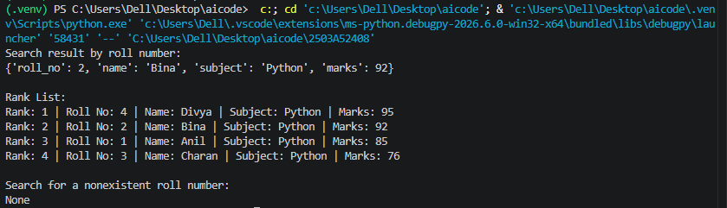
Task Description #6: Online Food Delivery Platform
An online food delivery application stores thousands of orders with
order ID, restaurant name, delivery time, price, and order status. The
platform needs to:
1. Quickly find an order using order ID.
2. Sort orders based on delivery time or price.
Student Task
• Use AI to suggest optimized algorithms.
• Justify the algorithm selection.

• Implement searching and sorting modules in Python.
Input:

# Online Food Delivery Platform

orders = [
{"order_id": 301, "restaurant": "Pizza Hub",
"delivery_time": 35, "price": 450,
"status": "Preparing"},
{"order_id": 302, "restaurant": "Burger Point",
"delivery_time": 20, "price": 250,
"status": "On the way"},
{"order_id": 303, "restaurant": "Spice House",
"delivery_time": 45, "price": 600,
"status": "Preparing"},
{"order_id": 304, "restaurant": "Food Corner",
"delivery_time": 15, "price": 180,
"status": "Delivered"},
]

# Create a dictionary index for order IDs
order_index = {o["order_id"]: o for o in orders}

def search_order(order_id):
"""
Search for an order by ID.
Average time complexity: O(1).
"""
return order_index.get(order_id)

def sort_by_delivery_time():
"""
Sort orders by delivery time, shortest first.
Time complexity: O(n log n) worst case.
"""
return sorted(
orders,
key=lambda o: o["delivery_time"]
)

def sort_by_price():
"""
Sort orders by price, lowest first.
Time complexity: O(n log n) worst case.
"""
return sorted(orders, key=lambda o: o["price"])

# Test cases
print("Search order by ID:")
print(search_order(302))

print("\nOrders sorted by delivery time:")
for order in sort_by_delivery_time():
print(order)

print("\nOrders sorted by price:")
for order in sort_by_price():
print(order)

print("\nSearch for nonexistent order:")
print(search_order(999))

Explanation:
The system uses a dictionary to find orders quickly by order ID and Merge Sort to arrange orders by delivery time or price.
Output:



